**IOT Based Driver Drowsiness Detection and Smart Alerting System**

##### **Abstract**

Generally, road accidents caused by a fatigue driver is a very serious problem causing in thousands of road accidents each year. According to the National Highway Traffic Safety Administration, every year about 1,00,000 police reported crashes involve drowsy driving. Drowsiness is one of the main causes of accidents alongside with other cases such as drunk driving, distractions, and so on. A way to overcome this issue would be with the use of sensors. They can detect, alert and can potentially save a person’s life. For drowsiness detection, there are certain bio-indicators that can detect the driver’s face for any signs of drowsiness and can alert them before anything harmful could happen. The buzzer will be activated if the driver’s eye-blink and the health parameters are found abnormal.

## Introduction

Driver fatigue has been the main issue for countless mishaps due to tiredness, tedious road condition, and unfavorable climate situations. Every year, the National Highway Traffic Safety Administration (NHTSA) and World Health Organisation (WHO) have reported that approximately 1.35 million people die due to vehicle crashes across the world. Generally, road accidents mostly occur due to inadequate way of driving. These situations arise if the driver is addicted to alcohol or in drowsiness. The maximum types of lethal accidents are recognised as a severe factor of tiredness of the driver. When drivers fall asleep, the control over the vehicle is lost. There is a need to design smart or intelligent vehicle system through advanced technology. This paper implements a mechanism to alert the driver on the condition of drowsiness or daydreaming. A camera monitors the driver’ eye blinking, eye closure, face detection, head posture, etc. with face landmark algorithm and Euclidean distance in the behavioral-based approach. These characteristics help to measure driver fatigue and instantly alert him with the help of voice speaker and forwarding an e-mail to a person (owner of vehicle) who can make him conscious. An e-mail is being transmitted to a destination using IoT module, which relies on wireless transmission. But, the proposed system is being integrated by a credit card-sized computer known as Raspberry Pi3 and Pi camera which can trace an eye movement thereby monitoring intensity of collision effects that happen at the time of accident and alerting the emergency ward of the hospitals or owners that are nearby to the accident spot along with GPS location of the accident.

### ****Materials Required for Building a Drowsiness Detector****

* Arduino Nano
* Eyeblink Sensor
* RF Transceiver Module
* HD12E & HD12D IC
* Buzzer
* 9V Battery
* 12V DC power supply

The **eye blink sensor** is used to detect the eye blinks and using which we can also detect the activities like the Drowsiness of the driver while driving. It works based on the technology of Infrared LED. It contains an Infrared transmitter and Receiver LED which is used to detect the eye blink. The working of the simple IR sensor is shown as below:

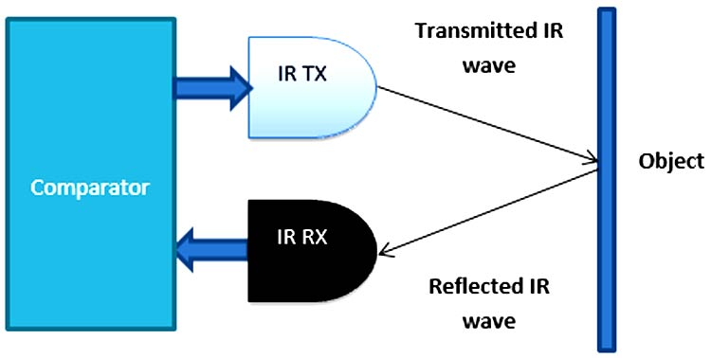

### ****Driver Drowsiness Detector Circuit Diagram****

Driver Drowsiness Detector consists of RF Transmitter and Receiver section. The transmitter section consists of an RF Transmitter and Eye Blink Sensor and the receiver side uses Arduino Uno with RF receiver for data processing. We previously used the same 433 MHz RF modules with Arduino for building projects like [Arduino RC Boat](https://circuitdigest.com/microcontroller-projects/simple-arduino-rc-boat-that-can-be-controlled-wirelessly-using-rf-module), [hand gesture controlled robot](https://circuitdigest.com/microcontroller-projects/accelerometer-based-hand-gesture-controlled-robot-using-arduino), etc. The circuit diagram for the transmitter and receiver section is given below.

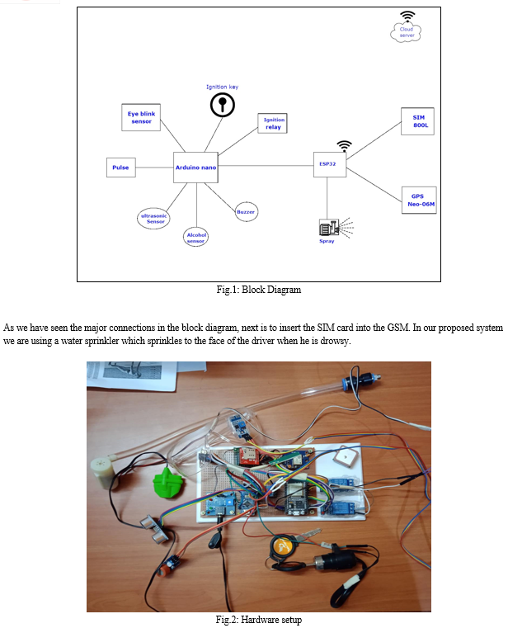

**Eye_Blink_Arduino.ino**

int flag=0;

int t1=0;

int t2=0;

void setup()

{

Serial.begin(9600);

pinMode(2,OUTPUT);

}

void loop()

{

int x=analogRead(A0);

//Serial.println(x);

if(x<400 && flag==0)

{

flag=1;

t1=millis();

}

else if(x>400 && flag==1)

{

flag=0;

t2=millis();

Serial.println(t2-t1);

if((t2-t1)>1000)

{

digitalWrite(2,HIGH);

Serial.println("Alert2!!!!!!!!!!!!!!!!!");

delay(2000);

digitalWrite(2,LOW);

}

else;

} }

**Existing Method**

In an intrusive approach, sensors are used to detect driver drowsiness by placing them on the driver's body, whereas in a non-intrusive approach, a camera is used for drowsiness detection by identifying yawning patterns, eyelid movement and head inclination.

**Conclusion**

Drowsy driving is one of the main causes of road traffic accidents around the world of around 21% and counting. By contrast, around 28% of accidents are caused by drunk driving and is increasing rapidly. According to the study of all the research papers at hand, each paper had a different approach with detecting driver drowsiness but followed similar practices in reducing/preventing it. From the comparations between other drowsy detection techniques, we have found that the eye state analysis-based techniques are the better methodology for detecting drowsiness/fatigue. Eye-state analysis- based methods has many benefits such as being non-intrusive and having low computation costs, high robustness, high accuracy and so on. Some of the research papers also measures certain parameters like pulse rate, temperature, alcohol consumption and based on that the vehicle stops/reduces its speed. Based on these findings, our goal is to implement a system that ensures the safety of the driver and avert vehicle accidents.